This Weeks Challenge





Can you be like Captain Tom?

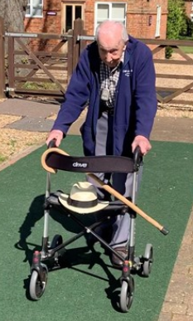

This week can you……

Run, Jog, walk, crawl, skate, ride 100 laps/ lengths of your garden, field, school playground?

Our challenge to you is can you give this a go.

#staysafestayactive